MONOLITHIC (single repo / single application)
Single Repository
│
├── Authentication
├── Products
├── Orders
├── Payments
├── Notifications
└── Reports

All these modules are part of one application
PROBLEM EXAMPLE
Suppose you want to make a small change in the Authentication module.
Even though only Auth changed:
- The entire application must be built again.
- The whole application must be tested.
- The complete application must be deployed.
So, a small change affects the whole project.
DISADVANTAGES OF MONOLITHIC APPLICAITON
1. Inefficient Scaling
Suppose:
- Authentication receives 1,000 users/day
- Products receive 100,000 users/day
In a monolith, you cannot scale only the Product module.
Instead, you must increase the resources (CPU, RAM, servers) for the entire application, which wastes money and resources
2.Large Team - code conflicts
Imagine:
- 20 developers
- Everyone works in the same repository.
Problems:
- Merge conflicts
- Developers accidentally modify each other's code
- Longer code reviews
- More communication overhead
- Higher maintenance cost
As the team grows, managing one codebase becomes difficult.
3.Bigger Project = Hard to Manage
As features increases:
- Auth
- Products
- Orders
- Payments
- Notifications
- Inventory
- Shipping
- Reviews
- Coupons
- Analytics
- Admin
The repository becomes huge.
Problems:
- Slow builds
- Long deployment time
- Difficult debugging
- Hard to find code
- Increased maintenance effort
A very large monolithic application becomes difficult to manage.

4. Difficult Onboarding
When a new developer joins:
They need to understand:
- Authentication
- Products
- Orders
- Payments
- Database
- APIs
- Business logic
This takes a lot of time because everything is connected in one project.
Result:
- Slower onboarding
- Lower productivity for new team members

5.Specific to language

MICROSERVICES
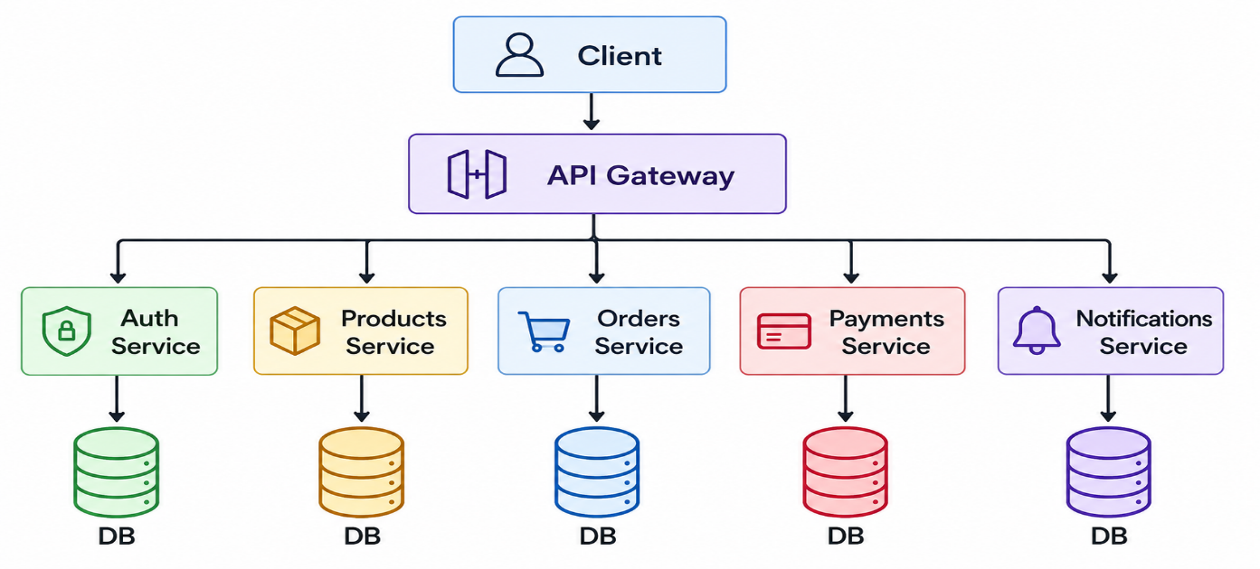
A microservice architecture breaks a large application into small, independent services.
Each service:
- Has its own source code (repository)
- Has its own database (recommended)
- Can be developed independently
- Can be tested independently
- Can be deployed independently
- Can be scaled independently
Each service performs one specific business function.
EXAMPLE OF DEPLOYMENT
Suppose you need to change the Authentication Service.
Only these steps are required:
- Build Authentication Service
- Test Authentication Service
- Deploy Authentication Service
Other services continue running without interruption.
Result:
- Faster deployment
- Less risk
- Smaller impact

ADVANTAGES OF MICROSERVICES
- Independent Scaling
- Smaller Teams
- Easier Maintenance
- Faster Onboarding
- Independent Technology Stack
- Fault Isolation

DISADVANTAGES OF MICROSERVICES
- communication complexity
- network latency
- data management
- Monitoring and Debugging
- Deployment Complexity

